1. **Scenario**:
   1. Where we don’t have any UI App.   
      Typical use case is in microservices where one micro service wants to access another micro service.
   2. In this case, we create a separate authorization server instead of implementing authentication and authorization code in each micro service.
2. 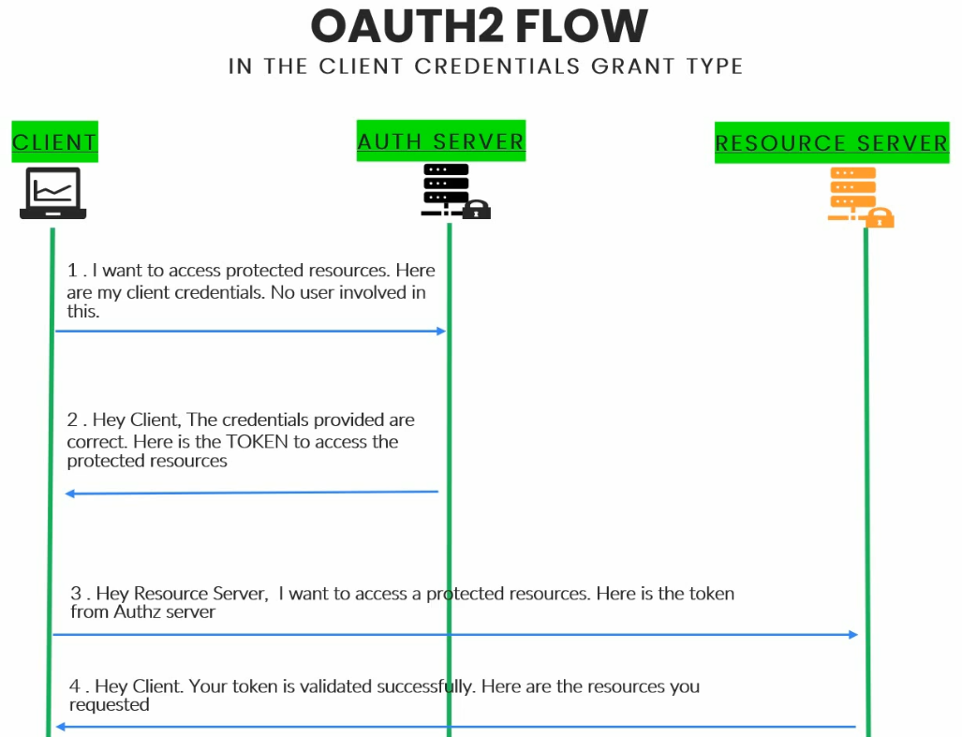
3. 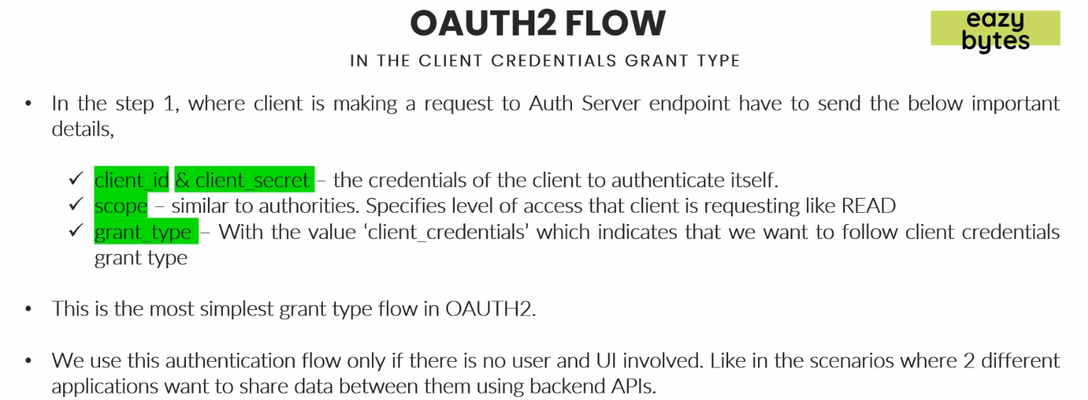
4. **NOTE**: Resource Owner (End-User) is not involved in this flow.